13 August 2024
YEAR 5/6 EXCURSION TO FLORIADE

EXCURSION INFORMATION FOR PARENTS / CARERS
Dear Parents and Carers,

The following details relate to an educational excursion to Floriade.

Purpose of excursion: The 5/6 Combined Band will perform at Stage 88 at Floriade, with the remaining students from 5/6 acting as their audience. Students will then have the opportunity to explore Floriade and use it as inspiration for their Unit of Inquiry ‘How We Express Ourselves’.
Date: Friday 20 September

Time: 9:30am depart Forrest Primary School, 12:45pm depart to Forrest Primary School. The Performance will run from 10:30 to 11:00. Families are welcome to come and watch the performance.

Place: Floriade, Stage 88

Transport: Hired Coaches

Teachers attending: Tara Durnin, Andrew Maurice, Kay Durnin, Endillion Kenyon and Erika Alling

Cost: $8.00

Bring: Students are to wear full school uniform. Students must bring lunch, a hat and a water bottle. There may be the opportunity to purchase something small such as an ice-cream or a drink, however, please ensure your child has lunch in case this is not possible on the day. Additionally, Floriade vendors are cashless so students will need to be responsible and bring a debit card with them should they wish to purchase anything.

Permission note due date: Thursday 12 September

It is customary for the school to request a financial contribution towards the cost of your child’s participation in this excursion. These contributions are voluntary. The school has made every effort to keep the costs of this activity at a reasonable level. We have an equity fund which can be used to provide financial assistance for families who are unable to make the requested contribution. If, however, there is insufficient funding available to meet the cost of the excursion, regrettably, we may not be able to proceed.

Behavioural expectations: Staff accompanying students on excursions will take all reasonable care while the students are in their charge to protect them from injury and to control and supervise their behaviour and activities.
Parents should be aware that staff members are not responsible for injuries or damage to property, which may occur on an excursion where, in all circumstances, staff have not been negligent. Parents should warn
children of the risks to themselves, to others and to property, of impulsive, wilful or disobedient behaviour. Students who indulge in such behaviours may be sent home.

Kind Regards,

Kay Durnin Tara Durnin
Year 5 Band Teacher Year 6 Band Teacher

YEAR 5/6 EXCURSION TO FLORIADE

PERMISSION NOTE – please return by Thursday 12 September

My child in class
will will not
attend the YEAR 5/6 EXCURSION TO FLORIADE, as outlined in the Excursion Information for Parents / Carers.
I agree to my child participating in the activities associated with this excursion mentioned previously. I have discussed with my child the need for expected behaviour on this excursion. I authorise the school to make arrangements for the welfare of my child (including medical or surgical treatment) in an emergency and I agree to meet the associated costs. I have provided to the school all medical information relevant to my child attending this excursion.
I agree that my child will be under the authority of the school for the duration of the excursion and that the school is authorised to return my child to school or home at my expense if the school considers that circumstances warrant such action. I give permission for my child to travel by private car, driven by a staff member or parent, in an emergency.
The Medical Information and Consent Form must be completed annually or sooner if there are changes to the information provided on the current one.
Do you need to provide a Medical Information and Consent Form?
Yes No
If yes, please collect one from the front office.
Will your child require medication to be administered during the excursion?
Yes No
If yes, please complete a Permission to Administer Medication (available from the front office).
Is there any additional information you need to provide to support your child’s participation in this excursion?
Yes No
If yes, please provide these details below.
_______________________________________________________________________________________
_______________________________________________________________________________________
Medicare number: ________________________________________________________________________
Private health fund & membership number (if applicable): ________________________________________

Parent / Carer name: ______________________________________________________________________
Signature: _______________________________________________ Date: __________________________

YEAR 5/6 EXCURSION TO FLORIADE

PAYMENT NOTE – please return by Thursday 12 September

(Receipt of payment alone does not give the school permission to take your child off the school grounds.)

The excursion cost is $8.00
Student name: _________________________________________________________ Class: ____________
I am paying the amount of: $
Payment methods are either:
QuickWeb is the preferred payment method for Forrest School. Access the method either through www.forrestps.act.edu.au or using the QR Code below.

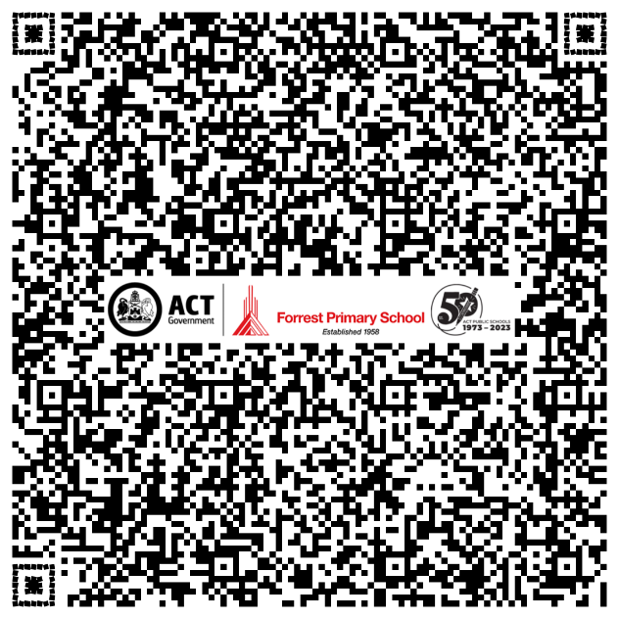
Please use the fee code: Floriade

Receipt number:
Or

At the school office using either EFTPOS or Cash (please provide the correct money)

